**ComS 309 Project Proposal**

**Group SS_4**

Willis Knox, Brett Santema, Axel Zumwalt, Morgan Smith

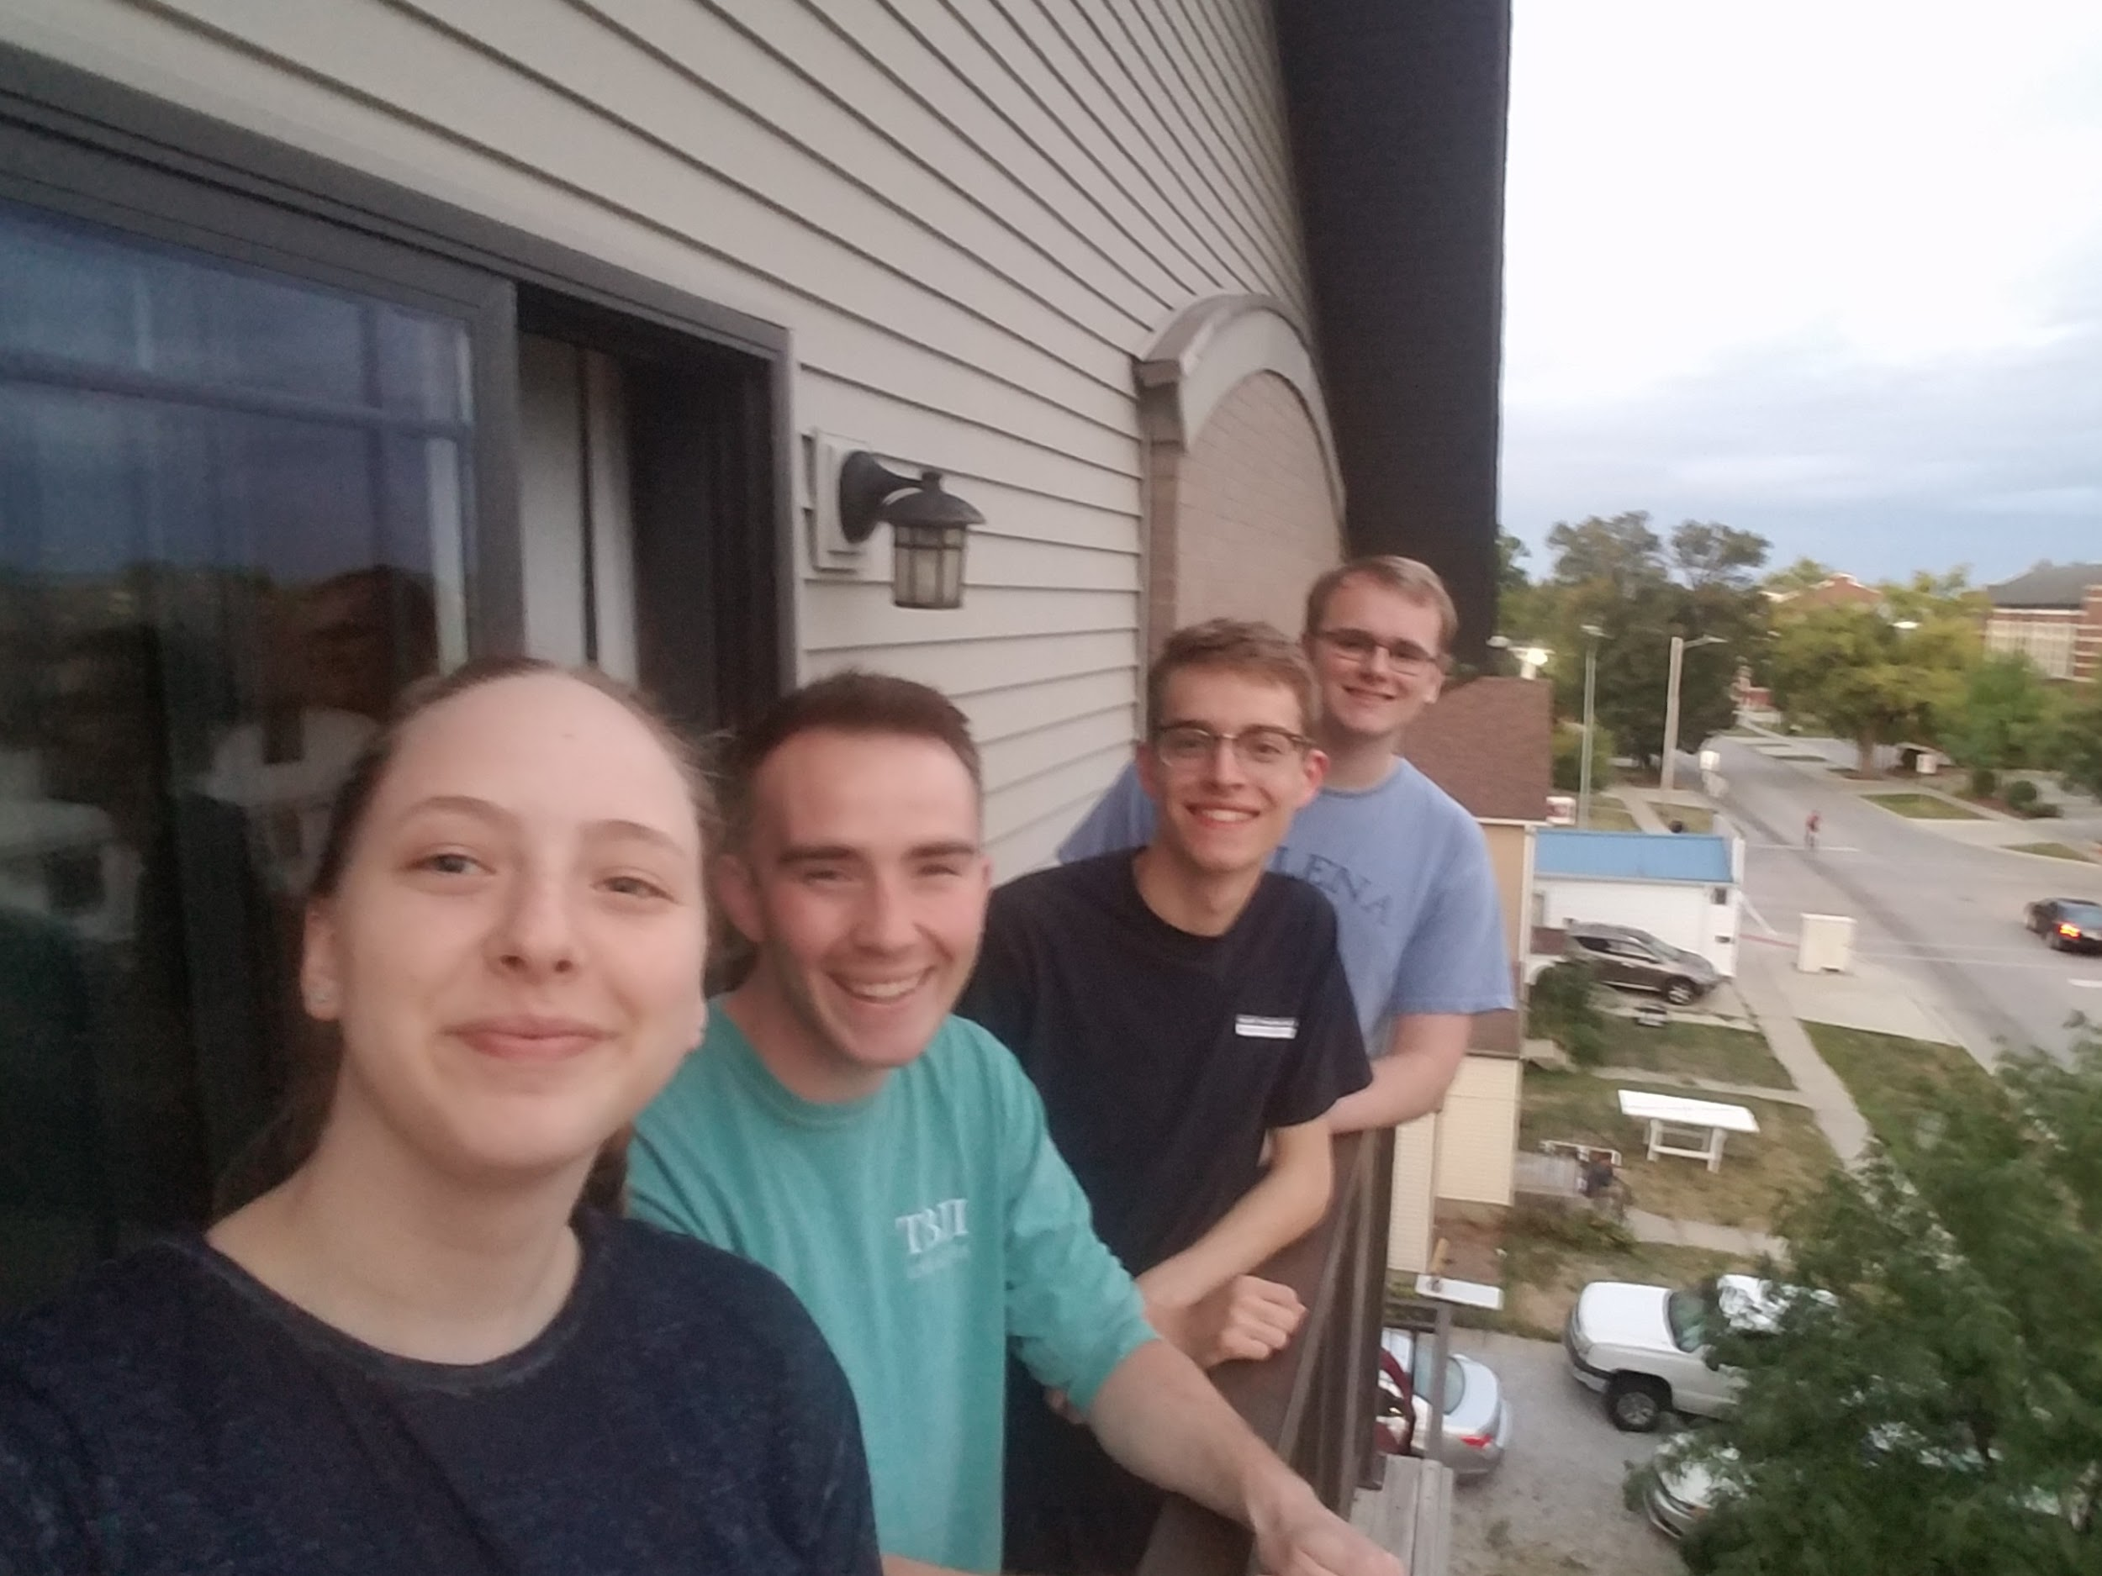

**Team Competency**

Willis: Tech Lead

Classes: 227/228, 327, 5th semester

Languages: Java, C#

Internships: Musco Lighting - Backend C# app development, data analysis software

Brett - Test Lead

Classes: 227, 228, 327, 311, 5th semester

Languages: Java, C/C++

Experience: Backend Java development

Axel: Repo Lead - Courses: 227, 228, 288, 5th semester

Languages: Java, C, Python

Internships: Collins Aerospace - Frontend/backend Java application development, Python automated testing

Softronics Ltd. - Embedded Programming

Morgan - Schedule Lead

Courses Taken: ComS 227, ComS 228, SE 319, CPRE 281, CPRE 288, 7th semester

Languages: Java, C

Experience: Computational biology / bioinformatics researcher in genome assembly.

Command line programming in Linux.

**Project 1**

**• Name:** OpenCampus

**• Description of project:** A better map of Iowa State University campus that shows more in depth features like water fountains, bathrooms, bike racks, classroom numbers, study spots, or other features that are useful to students and visitors on campus. Different time sensitive additions could include events or construction that will stay on the map for a specific duration. We can include user input to rank things like study spots and give feedback to other users. We will implement a fastest route option that takes into account walking, biking, or riding a bus. Different features can be filtered based on user’s need for example male, female, or unisex bathrooms. This would be a project that could be scalable to other campuses or locations in the future.

• **Language/Platform/libraries:** Java, Android Studio, Springboot, Google Maps API, MySQL

**• Large/Complex:**

* **New to us:** Client/Server interaction, mobile development, Android Studio and Springboot, Google Maps API, Database interaction/usage, user authentication
* **Client side**
  + Screens: Map screen, user filter screen, search screen, building floor plan view, feature comments and ranking, event list, login, help
* **Server side**
  + Database information on various location features and user input.
  + Process location information and use this as an input for fastest routes and locations.
  + Web app mobile development on Android.

**Project 2**

• **Name:** HungerHelper

• **Description of project:** A smart shopping app that will help you with grocery shopping and meal planning. This will use different product availability information from nearby grocery stores and provide this information to the app for searching. Easy meal planning that will optimize the amount of food available with your budget, and adhere to dietary needs for the average adult, or customized macronutrients and restrictions (i.e. low carb, keto, vegan, sugar free, gluten free).We could also incorporate ingredients the users already have available and suggest foods to complement these ingredients. We could allow the app to interact with external recipe websites or databases to suggest different meals. This can be scalable based on the number of people the recipe needs to fit, user needs, or other input.

• **Language/Platform/libraries**: Java, Android Studio, Springboot, Walmart Product Lookup API, AWS APIs

**• Large/Complex:** This project would need to interact with outside grocery store information, user inputs, potential recipes, and suggest different options that would meet these parameters.

* **New to us:** Client/Server interaction, mobile development, Android Studio and Springboot, Walmart Product Lookup API, Database interaction, user authentication
* **Client side**
  + Screens: Home screen / main menu, input and edit ingredients already available, store selection, search criteria, recipes, login, help
* **Server side**
  + Interaction with grocery databases and using this information to inform purchasing information, etc.
  + Web app mobile development on Android.